Check if there exists a subsequence with sum K
Problem Statement: Given an array nums and an integer k. Return true if there exist subsequences such that the sum of all elements in subsequences is equal to k else false.
Example 1:
Input : nums = [1, 2, 3, 4, 5] , k = 8
Output : Yes
Explanation : The subsequences like [1, 2, 5] , [1, 3, 4] , [3, 5] sum up to 8.

Example 2:
Input : nums = [4, 3, 9, 2] , k = 10
Output : No
Explanation : No subsequence can sum up to 10.
Algorithm
- Treat the problem as a decision tree where each item has two choices: include it or skip it.
- Recursively apply this decision process to the remaining items while updating the remaining target amount.
- If the target becomes zero, a valid combination has been found.
- If the target becomes negative or all items are exhausted, that path is invalid.
- Explore all possible combinations to determine if any subset matches the exact target.
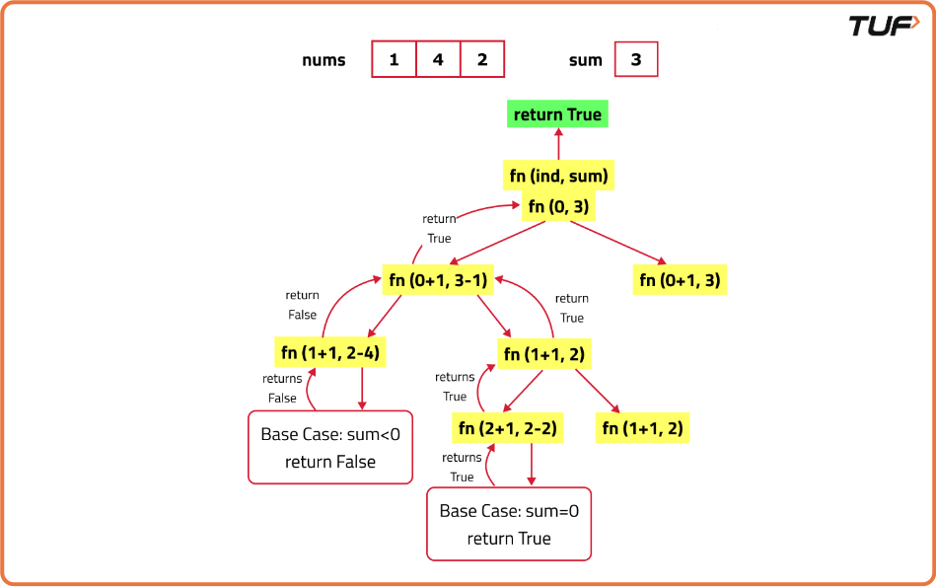
class Solution {
// This method recursively checks for the subsequence with the given sum
public boolean solve(int i, int n, int[] arr, int k) {
// Base case: if the sum k is 0, a subsequence is found
if (k == 0) return true;
// Base case: if k is negative, no valid subsequence can be found
if (k < 0) return false;
// Base case: if all elements are processed, check if k is 0
if (i == n) return k == 0;
// Recursive call: include the current element in the subsequence
// or exclude the current element from the subsequence
return solve(i + 1, n, arr, k - arr[i]) || solve(i + 1, n, arr, k);
}

// This method initiates the recursive process
public boolean checkSubsequenceSum(int[] nums, int target) {
int n = nums.length; // Get the length of the input array
return solve(0, n, nums, target); // Start the recursive process
}
}
Time Complexity: O(2^n), where n is the number of elements in the input array. This is because each element can either be included or excluded from the subsequence, leading to 2^n possible combinations.
Space Complexity: O(n), where n is the depth of the recursion stack. In the worst case, the recursion can go as deep as n levels, leading to a space complexity of O(n) due to the call stack.

